Northern and Northwestern Vermont Project Specific Action Plans
Lead utility  Affected utilities | GMP  GMP, VEC, BED, Global Foundries, WEC, VPPSA | Date of this plan:  January 2026
Description of deficiency | The Northern Vermont Reliability concern is the result of load growth, primarily driven by forecasted electrification of the transportation and heating sectors. The Vermont Road Map forecast – originally developed in 2023 for the Long Range Transmission Plan - assumes that future EV loads will have uncontrolled profiles, meaning that peak EV loads would overlap with peak base and heating lo ads. The voltage collapse concern arises as the result of an N-1-1 event on the 115 kV system, followed by tripping of multiple subtransmission lines to avoid thermal overloads on the 34.5 kV system.  Similarly, the Northwest Vermont Reliability concern is caused by the forecast of high load growth in EVs and heat pumps and therefore can be resolved using the same methodology. There is a low voltage concern (no voltage collapse) following an N-1-1 contingency on the bulk transmission system and subsequent tripping of multiple subtransmission and one 115 kV line to avoid thermal overloads.
Critical load level / timing of need | The critical load level is 505 MW in the Northern Vermont area, and the 2024 Long Range Plan shows a potential peak load of 580 MW during some winter peak events.  The timing of this concern is Winter 2033 under the Vermont Road Map, or VELCO’s highest load growth case.  The critical load level is 705 MW in the Northwest Vermont Area, and the 2024 Long Range Plan shows a potential peak load of 785 MW during some summer and winter peak events.  The timing of this concern is Summer 2029 under the Vermont Road Map, or VELCO’s highest load growth case.
Geographical area | The geographic area for the Northern Vermont area is all of Northern Vermont, bounded by the Plattsburgh, Williston, Granite, and Littleton substations.  The geographic region for the Northwestern Vermont area includes the Northern Vermont area and extends south to include the Middlebury and Florence areas. It is bordered electrically by the Plattsburgh, West Rutland, Granite and Littleton substations.
Transmission solution(s) & study status | The transmission solution proposed for the Northern Area is to add a second transmission line between VELCO’s Essex and Williston substations and to replace three 115/34.5 kV transformers (Queen City, Tafts Corners, and Barre). The cost estimate for this project is $153M. Additional analysis is needed to confirm the final upgrade design.  The transmission solution proposed for the Northwest Area is to rebuild the Middlebury to West Rutland 115 kV line and to replace the Middlebury 115/46 kV transformer. The cost of this project is $228M. Additional analysis is needed to confirm the final upgrade design.
NTA screening | The deficiencies for both areas screened in for full NTA analysis in the 2024 Vermont Long‐Range Transmission Plan (LRTP).
NTA solution(s) & study status | The 2024 Long Range Transmission Plan identified the load reduction needed in the Northern Study Area as 75 MW in 2033 that grows over time and 80 MW by 2033 in the Northwest Area. However, the VT Roadmap Forecast case does not account for existing EV charging control programs and residential/utility scale storage programs that actively reduce peak loads today.  The LRTP assumes an indefinite load reduction is required, however many of the NTA’s available today are finite resources. In order to analyze and design a viable NTA solution so that a wider variety of solutions could be compared to the transmission solution, it is crucial to know about both the power (MW) and energy (MWh) reduction needed.  Because the energy needs were not understood from the 2024 LRTP, GMP requested that VELCO perform an hour-by-hour energy assessment for 2033 known as an 8760 analysis to determine the critical load level within the study area and therefore the frequency, duration, and depth of any overloads that are expected to occur under the study’s assumptions. The time series analysis found that there is a maximum of 75 MW/230 MWh of load reduction needed in the Northern area in 2033, and 80 MW/318 MWh of load reduction in Northwestern Area in 2033. See figures 1 and 2, for load shapes on the peak days of these areas, respectively.  Following VELCO’s 8760 analysis of the Northern and Northwestern Areas, GMP performed additional NTA analyses in coordination with the NTA working group and the VSPC Geographic Targeting Subcommittee to refine the EV charging and storage dispatch assumptions that were used in the 2024 LRTP.  Northern Area:  The first step of this refined analysis was to update EV charging assumptions. VEC, and WEC provided GMP with their expected EV charging control contributions, using data from participation in current EV charging rates. GMP took this information along with the level of control that we expect to have in 2033 and applied a revised charging curve to reflect the appropriate amount of uncontrolled charging and a future managed charging program that pushes the “rebound” period later into the evening. This revised charging curve is based on illustrative revisions to GMP’s existing Rate 72 and 74 charging programs to encourage customers to charge their vehicles later in the night and to spread out the charging rebound effect that managed charging rates and exacerbate. Figure 3 shows the original and revised EV charging curves  For EV load management, within GMP’s territory it was assumed that a total of 65% of EVs will be under a control program in 2033. The current participation rate is roughly 71% of all EVs in GMP territory. Based on historical data it was assumed that a 2% opt-out rate for managed charging events in the future. Combined with uncontrolled daytime charging, GMP applied a revised EV controlled curve to 50% of vehicles in the Northern and Northwestern Areas to add a layer of conservatism and allow for customer opt-outs, uncontrolled daytime charging, and a decline in adoption rate over time. Figure 4 shows GMP’s adoption rate of managed charging programs over time.  In the forecast that was developed for the 2024 LRTP, it was projected that there would be 20.1 MW of uncontrolled EV charging load in the Northern Area in 2025 which was forecasted to increase to 92 MW of uncontrolled charging load by 2033. Affected DUs reported what percent of their future charging load they would be able to manage, and these results were included in the development of the revised charging curve assumptions.  With the EV control assumption updated, the needed load reduction dropped from 75 MW/230 MWh to 41.6 MW/101.5 MWh. Figure 5 shows the impact of EV management on the Northern area load shape.  GMP next updated the storage dispatch of existing storage available in the Northern Zone. The NTA Working Group made the decision to include only actively interconnected storage resources in the analysis since proposed projects have a degree of uncertainty in their interconnection timeline and power purchase agreement conditions. The Northern Area actively uses the following resources for peak shaving purposes:  Taking round trip efficiency and storage capacity degradation into account, this storage is enough to shift remaining forecasted peak loads later into the evening so that the load level in the Northern Area remains below the critical load level of 505 MW at all hours. With these two inclusions, the need for an NTA is deferred to beyond 10 years. Figure 6 shows the impact of this portfolio of storage on area loading.  Northwestern Area:  GMP applied the same methodology from the Northern Area analysis to the Northwest Area. This area has both winter and summer reliability exposure, so the summer exposure was analyzed. The winter exposure is very similar in shape and duration to the Northern Area curves discussed above.  The 2024 LRTP stated a need for an indefinite load reduction of 80 MW, although this was updated in VELCO’s time series analysis to a load reduction in the summer of 80 MW/318 MWh without any EV charging controls or storage dispatch included. See Figure 2.  Using the same methodology as above, EV charging controls were applied to GMP, VEC, and WEC charging loads. Using the same revised charging curves, the required load reduction decreased to 32 MW/106 MWh. See figure 7.  GMP next included active residential and utility scale batteries within the Northwestern Area that are currently being used to reduce monthly peak loads. Including residential storage, utility scale storage, and VEC and GlobalFoundries storage, there is:  Taking a conservative round trip efficiency of 85% into account, the available active storage in the Northwest Area is sufficient to maintain loads below the critical load level of 705 MW and defer the need for a transmission solution to beyond 10 years. Figure 8 shows the impact of the portfolio of active storage on Northwest Area loading.  Other Factors Affecting Deferral Timeline:  The NTA analysis discussion identified several additional assumptions that are expected to evolve in the upcoming 2027 Long Range Plan and may affect the deferral timeline. These uncertainties include:  - Revised EV load projects: The updated 2026 load forecast reflects a significant reduction in near-term EV load growth, with the adoption rate of EVs shifting until later in the 2030s.  - Revised heat pump impacts: The updated 2026 forecast also shows a large reduction in projected heat pump coincident peak loads, particularly in areas with natural gas service like the Champlain Valley.  - Proposed storage additions: There is 35.2 MW/140.2 MWh of proposed utility-scale storage in GMP’s territory in the Northern Area and 50.2 MW/ 200.2 MWh of proposed storage in GMP’s territory in the Northwestern Area. These additions increase operational flexibility and provide greater margin of error for dispatching storage to shift peaks away from the evening and early morning hours.  - Growth in behind-the-meter storage: Continued adoption of behind-the-meter storage for resiliency purposes is expected to further increase the amount of load that GMP can shift during peak hours.  - ISO-NE Planning Procedure 7 revisions will allow for winter planning ratings to be based on a lower ambient air rating than today, likely increasing winter ampacities on subtransmission and transmission. Further, FERC Order 881 calls for real-time operational ratings to be based on ambient temperatures. For winter concerns, like in the Northern area, this will result in further margins since peak loads only occur on the coldest days.
  Northern Area Active Storage
   | MW | MWh
  GMP Residential Storage (BTM) | 11.7 | 31.4
  GMP Utility-Scale Storage | 16.1 | 45.3
  VEC Storage | 7.5 | 30.4
  GF Storage | 15 | 60
  Total | 50.3 MW | 167.1 MWh
  Northwestern Area Active Storage
   | MW | MWh
  GMP Residential Storage (BTM) | 15.9 | 42.7
  GMP Utility-Scale Storage | 24.1 | 72.9
  VEC Storage | 7.5 | 30.4
  GF Storage | 15 | 60
  Total | 62.5 MW | 206.0 MWh
NTA/TA hybrid solution(s) & study status | There is no need for a hybrid transmission solution since the exposure can be managed by leveraging existing storage and EV resources, as well managing projected future EV charging load at a rate consistent with GMP’s forecasted capabilities.
Solution selection | As a result of the analysis described above, GMP and the NTA Working Group have concluded that the Northern and Northwest deficiencies are deferred though the above analysis. There is no need to plan and build a traditional transmission solution for the Northern and Northwestern Areas at this time for this reason. By applying EV charging management at rates that exist today to future/revised EV charging loads and derating them at an amount to allow for opt-outs and drop in enrollment over time, the load reduction needs are less in amplitude and duration in both study areas. Further, accounting for peak shaving behavior of residential and utility-scale storage demonstrates that peak loads can be maintained below the respective critical load levels while preserving sufficient evening capacity to fully recharge storage and pre-position it for the next peak event.  Looking ahead to the next three-year long range planning cycle, the assumptions refined as part of this NTA study should be tracked by all affected DUs. Continued tracking will support the most accurate representation of all flexible resources on the Vermont distribution system and ensure that resources actively used to shape peak loads and reduce customer costs are appropriately reflected in future planning analyses.
Cost allocation | N/A
Public outreach | Both VELCO and GMP conducted routine public updates through the VSPC. The NTA analysis was discussed at the following meeting times:  - 1/22/2025 – VSPC Quarterly Meeting  - 4/30/2025 – VSPC Quarterly Meeting  - 7/09/2025 – Geographic Targeting Subcommittee Meeting  - 7/16/2025 – VSPC Quarterly Meeting  - 9/30/2025 – NTA Working Group Meeting  - 10/23/2025 – NTA Working Group Meeting  - 10/27/2025 – Geographic Targeting Subcommittee Meeting  - 10/29/2025 – VSPC Quarterly Meeting  - 11/6/2025 – NTA Working Group Meeting  - 11/13/2025 – Geographic Targeting Subcommittee Meeting  All publicly available materials have been uploaded to VSPC website:  https://www.vermontspc.com/subcommittees  Additional public engagement has been conducted through PUC investigation into LRTP: case no 24-3351-INV.
Implementation | The need for transmission upgrades in the Northern and Northwestern Areas is deferred by updating the load shapes to reflect the impacts of existing EV charging management and battery storage programs. The next Long Range Plan should consider these active and interconnected resources as part of the system load before conclusions about whether transmission solutions are needed are drawn. The distribution utilities can support this effort through tracking and sharing the following metrics:  - EV charging management enrollment rates, expressed as a percentage of vehicles within each service territory.  - Customer Opt-out rates for those enrolled in EV charging management programs.  - Coincident peak EV load reductions, quantified as the megawatts of EV charging reduced during system peak hours because of management programs.  - Planned program refinements, including changes to Time-Of-Use windows, event frequency, event duration, etc.)  - Behind-the-meter (BTM) and utility scale storage capacity, reported in MW/MWh at each substation or bus, along with associated control strategies and dispatch methodologies.  - Available flexible load capacity, including C&I customers, reported in MW/MWh at each substation and operational strategy used to call these events.  Further work is required to identify and track performance-based metrics that capture the reliability and effectiveness of peak-shifting resources such as storage dispatch, day-ahead EV charging events, and flexible load management (FLM) programs. VELCO can support this effort by identifying the data needs of their planners and system operators to build confidence in the performance of BTM peak-shifting resources and their impacts on bulk transmission flows.
Factors that may affect project timing | N/A, since there is no build out needed.

Figures:

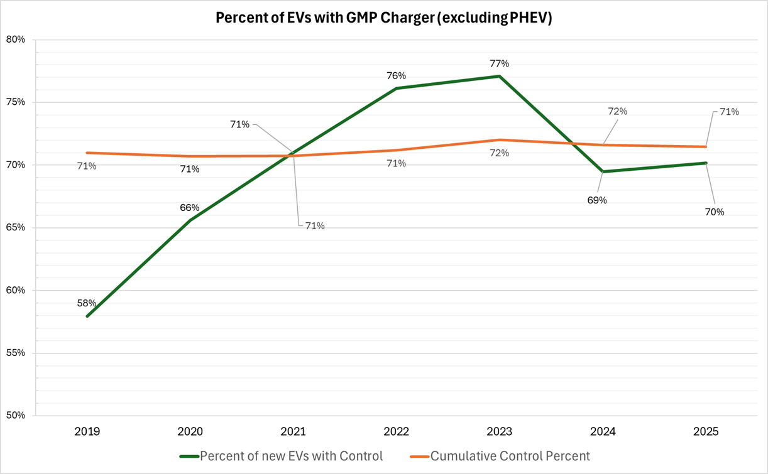
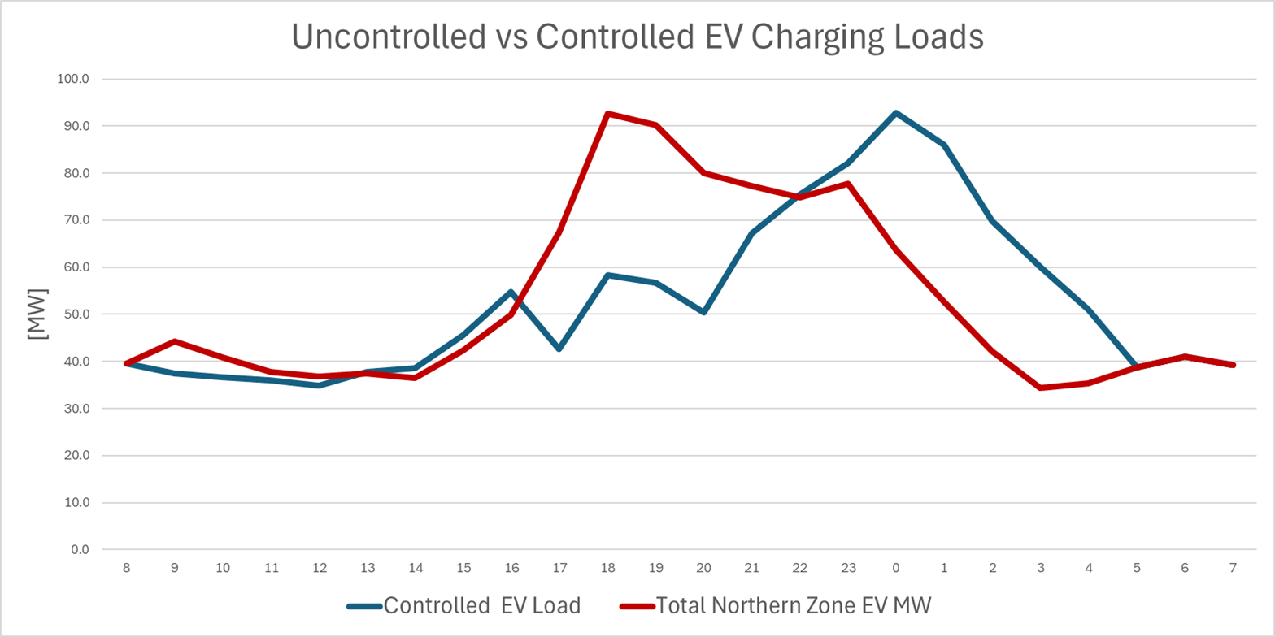
Figure 4: GMP'S EV CHARGING MANAGEMENT ADOPTION RATES FOR FULLY ELECTRIC VEHICLES OVER TIME.

FIGURE 3: Original Uncontrolled EV Charging Curve used in the long range plan (Red) vs. the revised ev charging curve baed on revised tou and event-based programs with adoption levels at 50% load reduction rates for gmp and vec, and 33% for WEC.

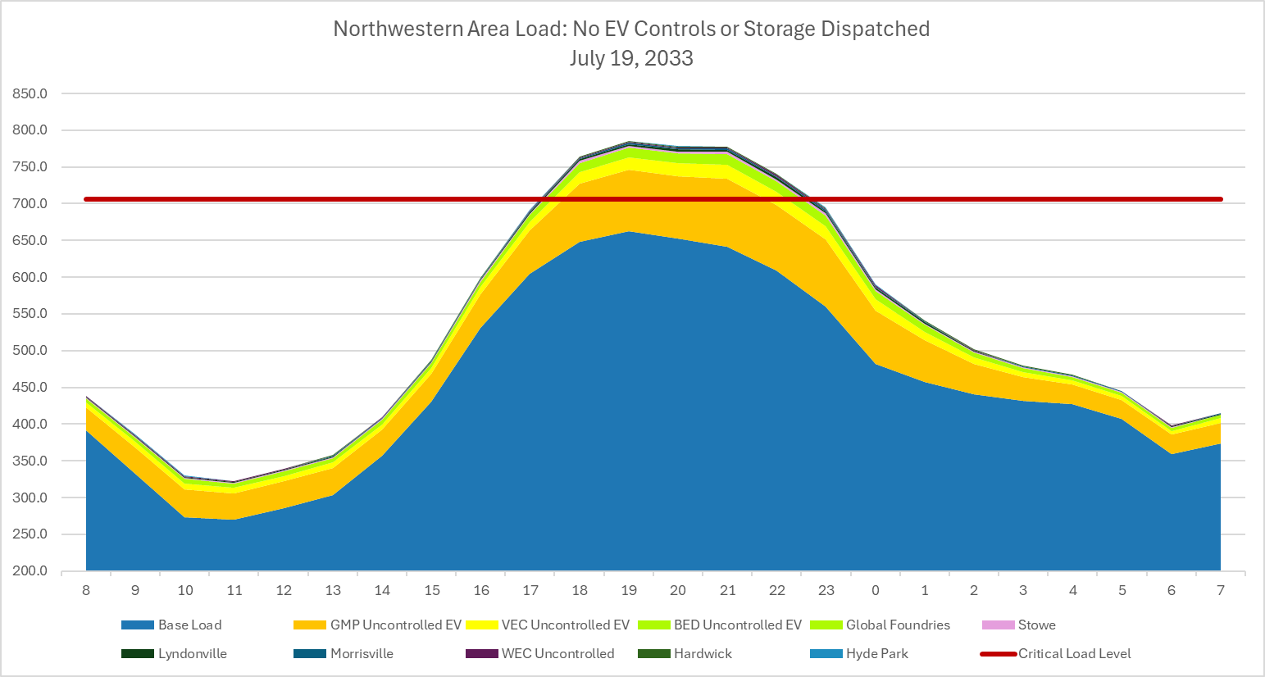
Figure 7: NORTHWESTERN AREA LOAD WITH ALL EV CHARGING CONTROLS APPLIED.
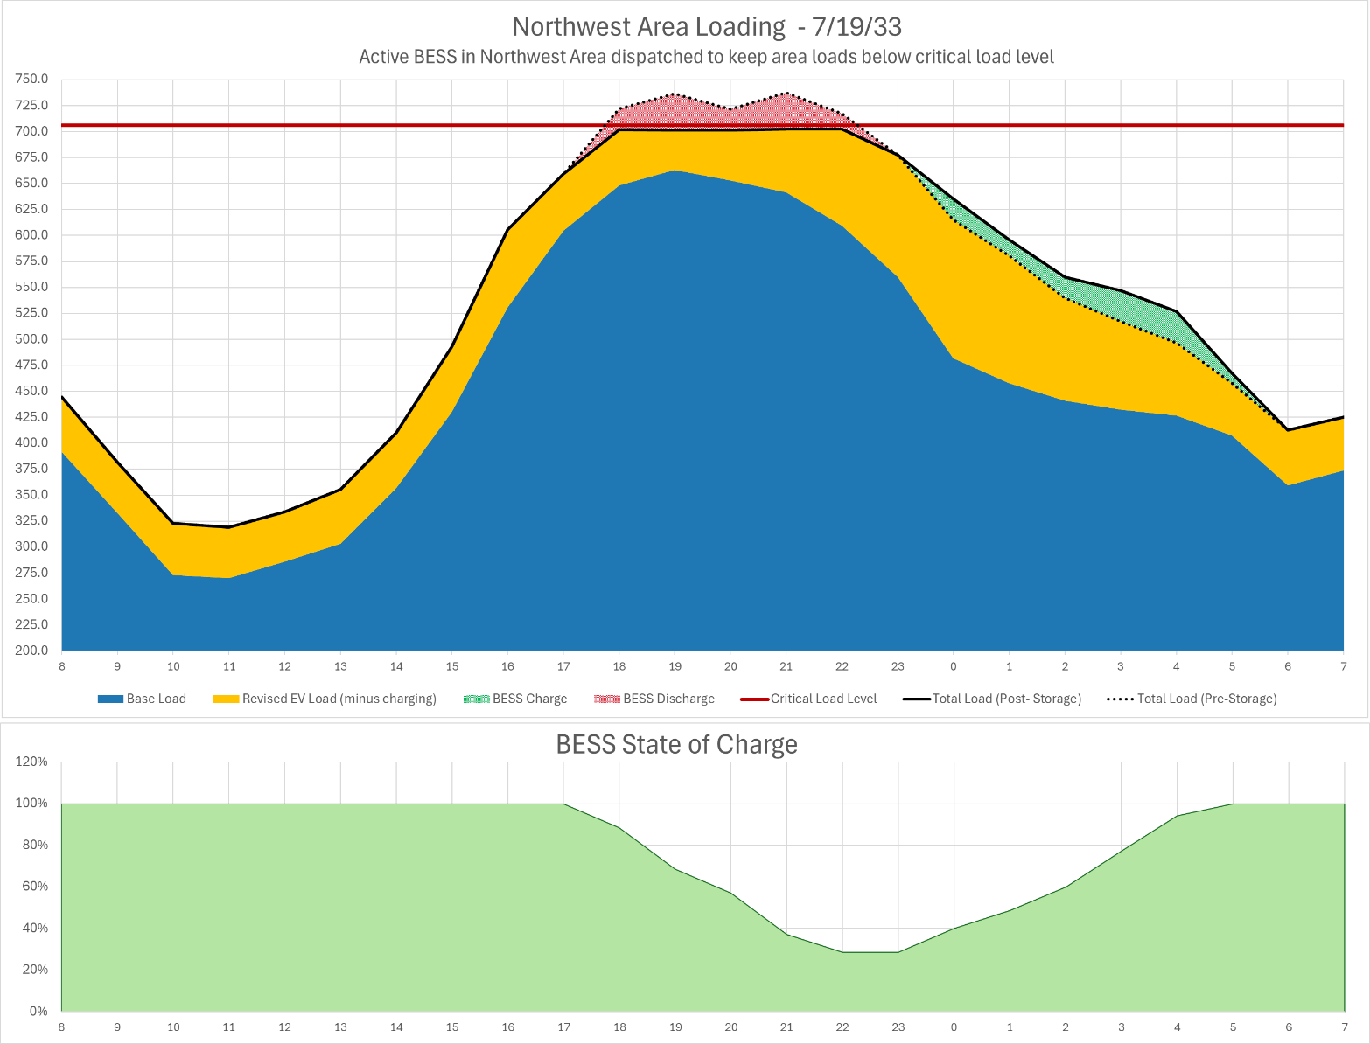
Figure 8: Northwest area load with active storage dispatched to keep loads below critical load level.

