Northern and Northwest Area Reliability Plan
This document serves as Green Mountain Power’s (GMP) reliability plan for the Northern and Northwest Reliability areas identified in the 2024 Long Range Transmission Plan.
Summary
VELCO’s 2024 Long Range Transmission Plan (LRTP) identified potential reliability concerns in Northern and Northwest Vermont in the 10-year planning horizon beginning in 2033. These concerns arise under the assumptions of high load growth due to electric vehicle (EV) adoption without charging management programs in place alongside additional heat pump adoption. As a follow up to the 2024 LRTP, under Docket 7081, GMP as the lead distribution utility (DU), has led the Non-transmission Alternative (NTA) Working Group, the Geographic Targeting Subcommittee, and the Vermont System Planning Committee (VSPC) general membership in the following analysis to determine a suitable non-transmission alternative for the identified concerns. This has included:
- A VELCO-led 8760 time-series analysis of each reliability area to determine critical load levels.
- The update of assumptions behind EV charging control programs to illustrate future programs under high-growth scenarios.
- The update of assumptions to include the peak-shaving behavior of existing storage resources prior to transmission contingencies occurring, as they operate today.
- The participation in various working groups and subcommittees, including the NTA Working Group, the Geographic Targeting Subcommittee, as well as the participation in PUC investigation into LRTP: case no 24-3351-INV.
Following GMP’s NTA analysis (described in the following pages), GMP and VELCO have confirmed that the need to build a transmission solution has been deferred beyond the 10-year study horizon by considering existing peak-shaving storage resources and by including EV charging control at today’s enrollment rates. If load growth happens at the rate studied in the 2024 LRTP, the following actions will need to be taken by the DUs:
- Refinement of EV charging management programs to reduce the charging spike following a time-of-use event and to encourage more charging in the late evening and early morning hours.
- Tracking of metrics related to peak management, including but not limited to EV charging management adoption rates, EV program coincident-peak load reduction, and active and proposed storage at each substation.
The following pages describe the background behind the 2024 LRTP and subsequent NTA analysis, the proposed accounting for existing NTA resources, and the actions that are needed if load growth occurs at the rate shown in the 2024 LRTP. The Project-Specific Action Plans for both the Northern and Northwest areas are included as an appendix to this Reliability Plan.

Background:
On June 28, 2024, VELCO published the 2024 Vermont Long Range Transmission Plan (LRTP, The Plan) which identified the potential for reliability concerns on the transmission system under scenarios of high load growth and multiple transmission elements out of service. The LRTP identified the Northern and Northwest areas of concern as the two areas which require a Non-Transmission Alternative analysis (NTA analysis) under Docket 7081 due to their timing being within a ten-year horizon.

The geographic area for the Northern Vermont zone is bounded by the Plattsburgh, Williston, Granite, and Littleton substations. The Northern Vermont Reliability concern is the result of load growth, primarily driven by forecasted electrification of the transportation and heating sectors. The Vermont Road Map forecast – originally developed in 2023 for the Long Range Transmission Plan - assumes that future EV loads will have uncontrolled profiles, meaning that peak EV loads would overlap with peak base and heating loads. The voltage collapse concern arises as the result of an N-1-1 event on the 115 kV system, followed by tripping of multiple subtransmission lines to avoid thermal overloads on the 34.5 kV system. The critical load level is 505 MW in the Northern Vermont area, and the 2024 Long Range Plan shows a potential peak load of 580 MW during some winter peak events. The timing of this concern is Winter 2033 under the Vermont Road Map, or VELCO’s highest load growth case.

Figure 1 shows the original load shape from the 2024 LRTP in the Winter of 2033. There is a peak load reduction of 75MW/230MWh, and there is a need for both a morning and night load reduction in the Northern area on some days.

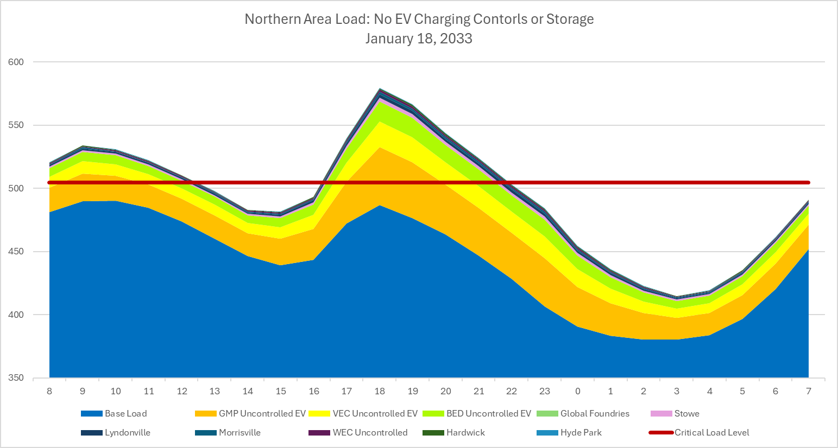
Figure 1: Northern Zone Load from VELCO's frequency/duration analysis as part of the follow-up to the 2024 LRTP.
The geographic region for the Northwestern Vermont area includes the Northern Vermont area and extends south to include the Middlebury and Florence areas. It is bordered electrically by the Plattsburgh, West Rutland, Granite and Littleton substations. Similarly to the Northern zone, the Northwest Vermont Reliability concern is caused by the forecast of high load growth in EVs and heat pumps and therefore can be resolved using the same methodology. There is a low voltage concern (no voltage collapse) following an N-1-1 contingency on the bulk transmission system and subsequent tripping of multiple subtransmission and one 115 kV line to avoid thermal overloads. The critical load level is 705 MW in the Northwest Vermont Area, and the 2024 Long Range Plan shows a potential peak load of 785 MW during some summer and winter peak events. The timing of this concern is Summer 2029 under the Vermont Road Map, or VELCO’s highest load growth case.
Figure 2 shows a Summer peak day from the original 2024 LRTP in the Northwest Area. There is a peak load reduction need of 80 MW / 318 MWh in this zone on a peak summer day in July 2033.

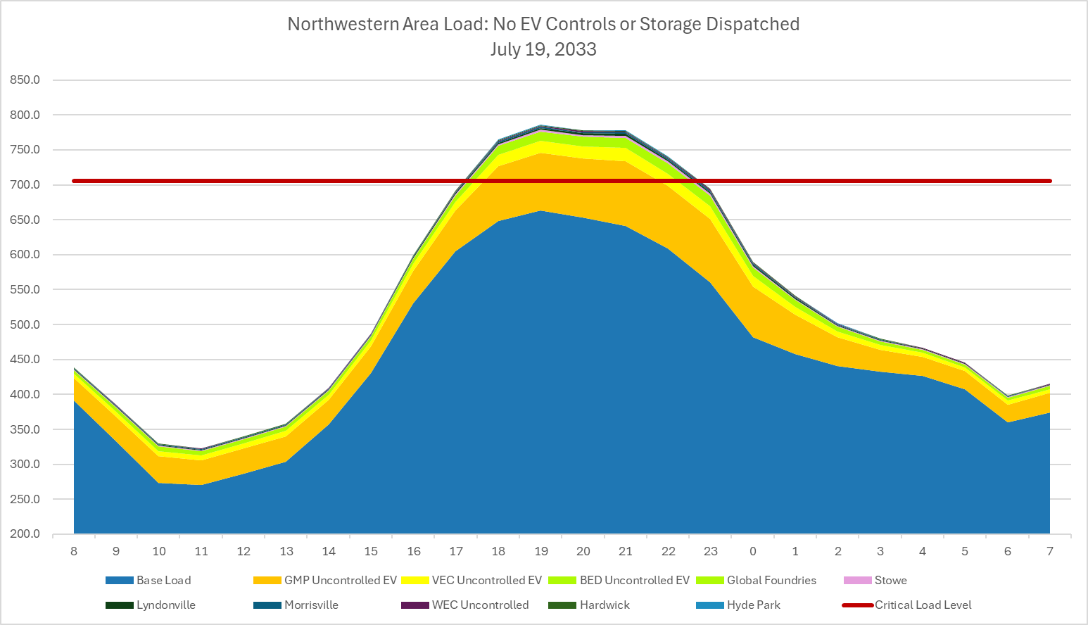
Figure 2: Northwest Area load from VELCO's frequency/duration analysis as part of the follow-up to the 2024 LRTP.
As part of the 2024 LRTP, VELCO proposed the following transmission upgrades to address these reliability concerns:
- Northern Area: Add a second transmission line between VELCO’s Essex and Williston substations and replace three 115/34.5 kV transformers (Queen City, Barre and Tafts Corners). The cost estimate is a total of $153M.
- Northwest Area: Rebuild the Middlebury- West Rutland 115 kV transmission line and replace one 115/46 kV transformer (Middlebury). The cost estimate for this work is a total of $229M.
No hybrid transmission/non-transmission alternative solution was proposed for either of these areas.
In the months following the publication of the 2024 LRTP, GMP, VELCO and the other DUs worked closely together to revise assumptions that were used in the 2024 LRTP and to perform additional analysis to determine the applicability of storage of EV charging management to defer these reliability concerns. Both VELCO and GMP conducted routine public updates on the additional analysis performed as part of the LRTP and on the NTA analysis through the VSPC. The NTA analysis was discussed at the following meeting times:

- 1/22/2025 – VSPC Quarterly Meeting
- 4/30/2025 – VSPC Quarterly Meeting
- 7/09/2025 – Geographic Targeting Subcommittee Meeting
- 7/16/2025 – VSPC Quarterly Meeting
- 9/30/2025 – NTA Working Group Meeting
- 10/23/2025 – NTA Working Group Meeting
- 10/27/2025 – Geographic Targeting Subcommittee Meeting
- 10/29/2025 – VSPC Quarterly Meeting
- 11/6/2025 – NTA Working Group Meeting
- 11/13/2025 – Geographic Targeting Subcommittee Meeting
- 1/21/2026 - VSPC Quarterly Meeting
- 2/12/2026 - VSPC Special Meeting

All publicly available materials have been uploaded to the VSPC website. GMP, VELCO, BED, and VEC also provided additional public engagement through PUC investigation into LRTP: Case No. 24-3351-INV.

As a result of this coordination, GMP, the NTA Working Group, the Geographic Targeting subcommittee, and the VSPC general membership have reached a consensus that these transmission concerns have been adequately deferred through the assumptions that are discussed below.

Description of Non-Transmission Alternative Solution:

In addition to the high levels of load growth forecasted in the 2024 Long Range Transmission Plan, the Plan also changed several critical assumptions from previous year’s plans resulting in higher 2033 load levels than previous plans. The two assumptions that this reliability plan discusses in detail are those behind existing EV charging management programs and existing distributed and utility scale storage systems.

Electric Vehicle Charging Management Updates:

The 2021 LRTP assumed that 75% of EVs would be under charging management programs in the future, while the 2024 LRTP assumed 0% of EVs would be under a management program. To date, many DUs are already effectively deploying EV charge management programs. Subsequently the NTA working group worked to better understand and quantify the levels of existing charging management that exist today and ensured that these assumptions were included as part of the NTA analysis.

The NTA Working Group received data from GMP, VEC, and WEC about enrollment rates in their current EV management programs who estimated their capabilities at 65%, 50%, and 33% of registered EVs respective to their service territories. The NTA working group then applied a derating factor, further reducing the estimated capabilities to 50%, 40%, and 25% for the EV load in each DU’s territory. The derating is meant to account for some daytime charging and builds in a layer of conservatism in case future EV enrollment rates drop slightly.

GMP then applied a revised EV charging curve to each DU’s EV load in the study cases for the percentage of vehicles that are assumed to be under a managed charging program and left the remainder of vehicles under an uncontrolled charging shape.

Figure 3 shows the difference between the original EV charging curve that was used in the LRTP and the illustrative managed curve that was developed for the NTA analysis. The difference between these two curves is the timing of the peak charging load; the controlled curve shifts the peak later into the night while also reducing the “bounce back” effect that is seen in a time-of-use program. The total energy remains the same between the two curves, meaning that all customers have vehicles that are fully charged by the morning commute.

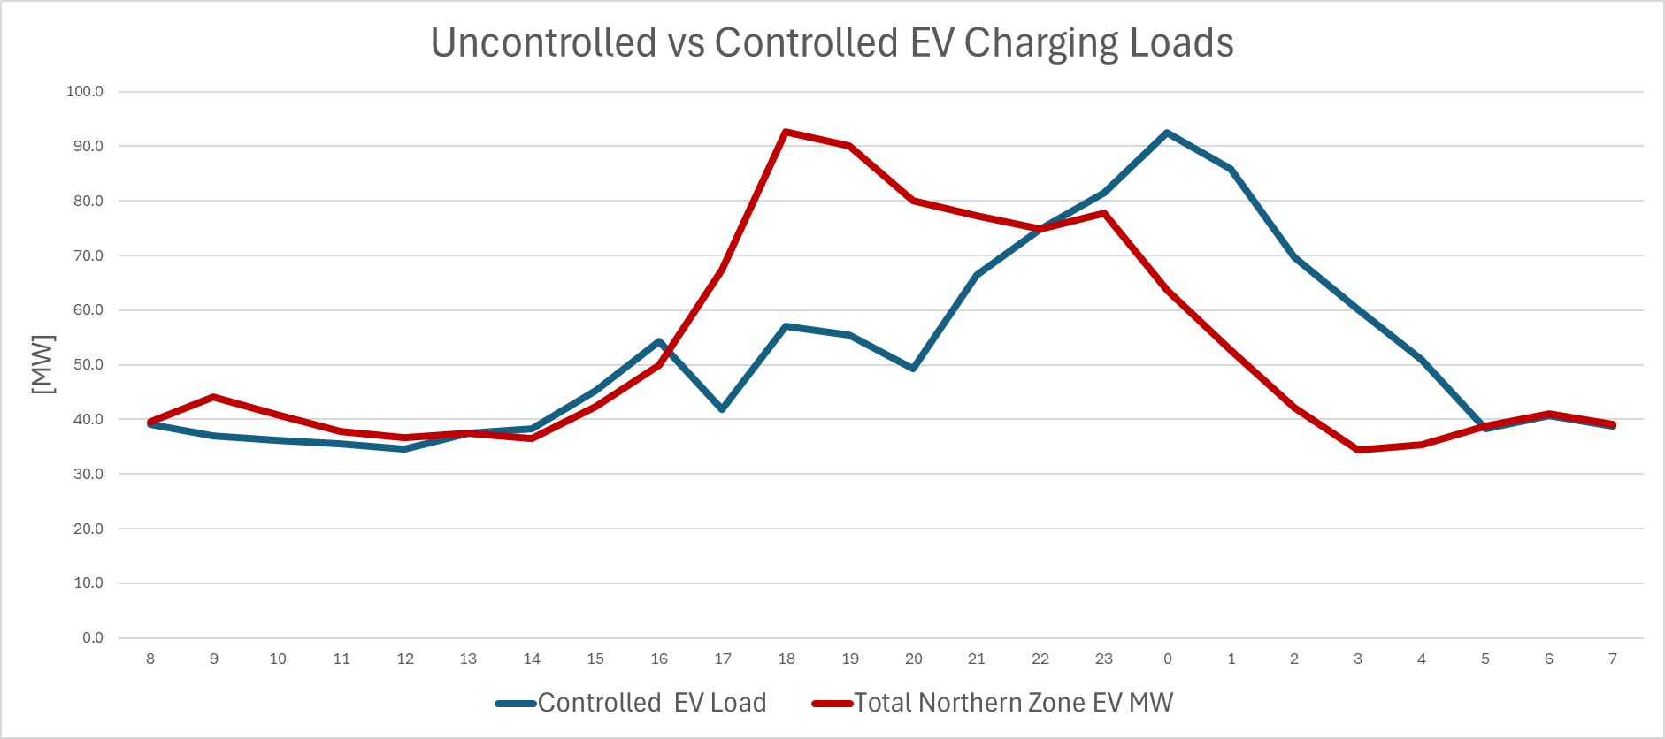
Figure 3: Original EV charging shape (red) vs the combination of uncontrolled charging and revised managed charging at today's adoption rates (blue).

Using Existing Storage for Peak Management:

The other notable assumption that was updated as part of the NTA analysis was the inclusion of peak shaving storage that is already interconnected on the system. GMP alone has over 50 MW of distributed and utility scale storage that it dispatches each month to reduce GMP’s load at the Vermont’s peak hour, thus reducing its Regional Network Service (RNS) payments each month. GMP also uses this storage to reduce its Forward Capacity Market (FCM) payments during ISO-NE’s single highest load hour each year. Since this storage is dispatched agnostically to any transmission system needs, it was determined by the NTA Working Group that existing storage could be used as a resource to shift energy around and keep loads below critical load levels.

Northern Area:

The Long Range Plan found that there was a need for 75 MW/ 230 MWh of load reduction in 2033 in the Northern area. The first step that GMP and the NTA working group took was to revise the EV charging load shape to better reflect a redesigned tariff at adoption rates that are consistent with today’s adoption rate as discussed in the previous section of this plan. After doing this, the load reduction need reduced from 75 MW/230 MWh to 42 MW/102 MWh as shown in Figure 4.

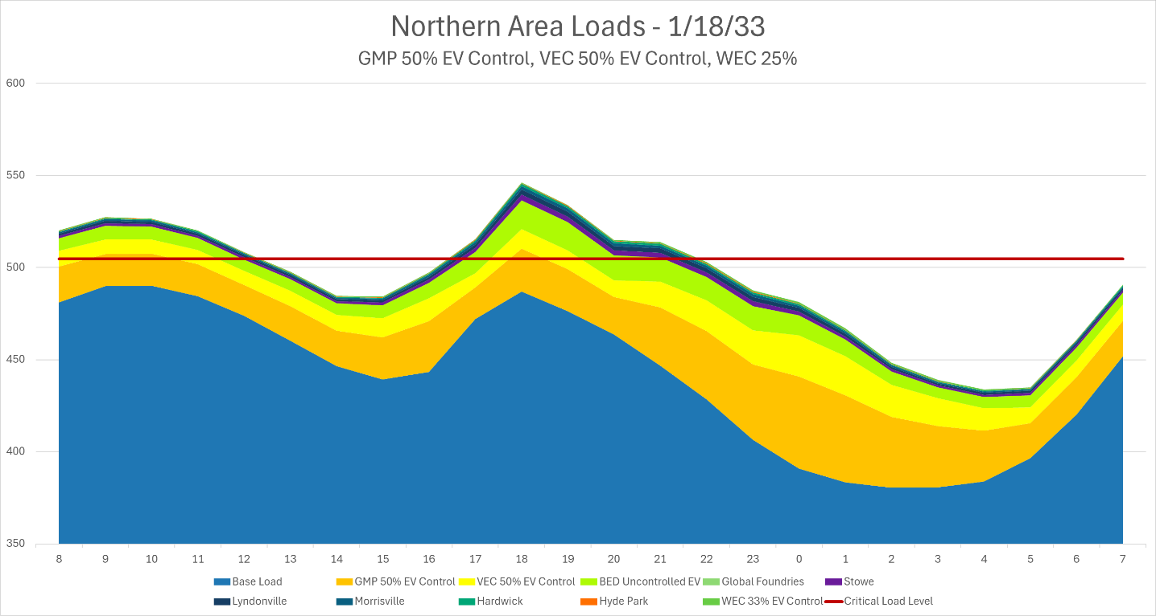
Figure 4: Northern area load shape after including EV charging management programs.

The NTA Working Group then determined that existing storage resources that are used monthly for peak shaving should be included in the NTA analysis since they are already used on the coldest days of the year and will continue to be used this way. The Northern area currently has the following storage resources being used for peak shaving:

Northern Area Active Storage
 | MW | MWh
GMP Residential Storage (BTM) | 11.7 | 31.4
GMP Utility-Scale Storage | 16.1 | 45.3
VEC Storage | 7.5 | 30.4
GF Storage | 15 | 60
Total | 50.3 MW | 167.1 MWh

There is enough storage capacity interconnected today in the Northern area to shift the remaining peak loads into the early morning hours and defer the need for a transmission solution, even when considering a conservative 85% round trip efficiency into account for the batteries. Figure 5 shows the resultant load profile with storage and EV managed included, as well as the state-of-charge of the batteries in this region. Notice how the batteries are able to return to 100% charge over the course of a day, so that if multiple peak days occur in a row, these resources will remain effective.
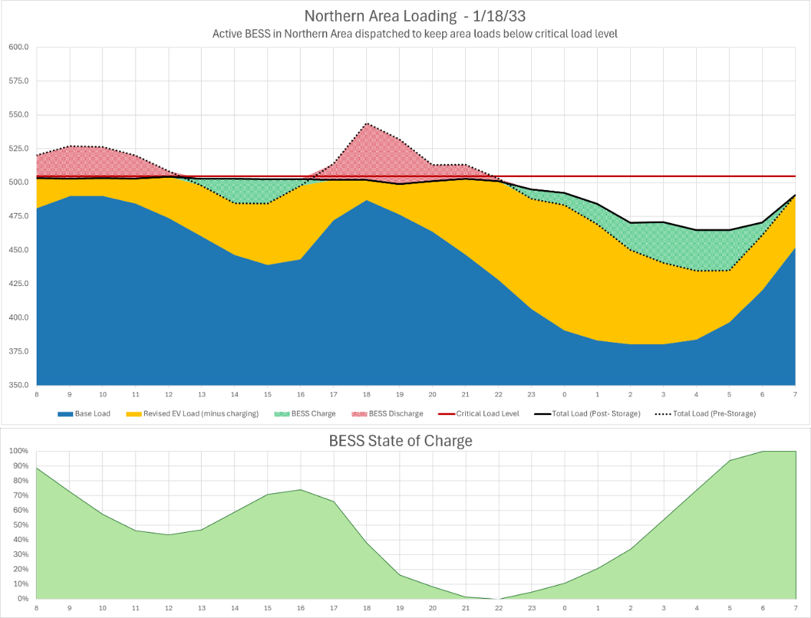
Figure 5: Northern Area load, including EV management and storage dispatch.
Northwest Area:
The analysis performed for the Northwest area is very similar to the Northern area, with the exception that the Northwest area also has a reliability exposure in the summer months. After applying the same assumptions around EV charging management as the Northern area, the load reduction needs reduced from 80 MW/ 318 MWh to 32 MW / 106 MWh as shown in Figure 6.

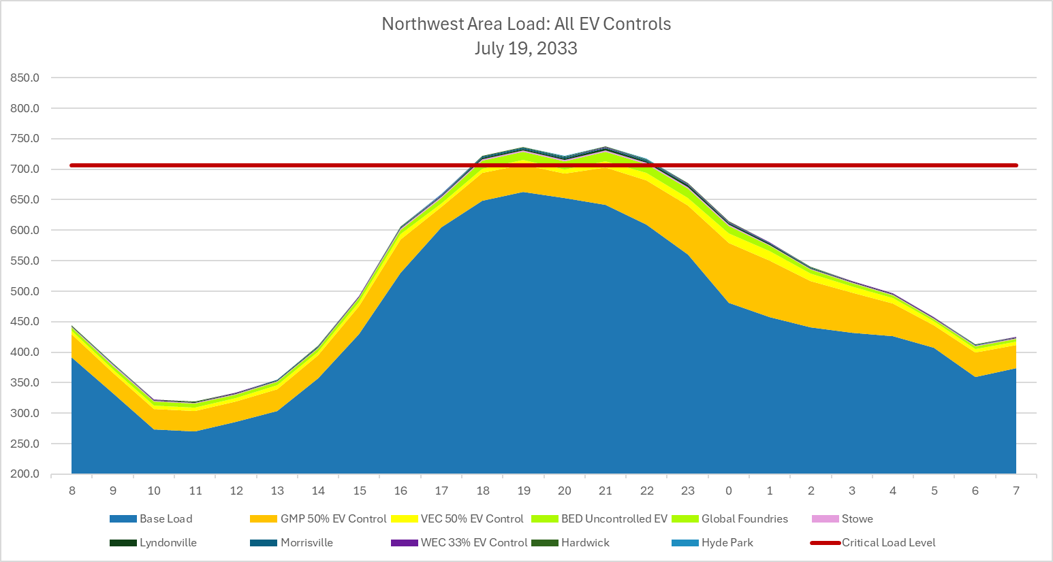
Figure 6: Northwest Area load with EV management taken into account.
The existing storage resources in the Northwest area were then applied to reduce the peaks further. As shown in the following table, there is enough storage in the region to defer the identified transmission need, similarly to the Northern area. Figure 7 shows the Northwest area load following EV management and storage dispatch as well as the state of charge of the batteries in this zone. All storage has the time to recharge to 100% by the following morning, in case a multi-day heatwave causes similarly high loads for more than one day.
Northwestern Area Active Storage
 | MW | MWh
GMP Residential Storage (BTM) | 15.9 | 42.7
GMP Utility-Scale Storage | 24.1 | 72.9
VEC Storage | 7.5 | 30.4
GF Storage | 15 | 60
Total | 62.5 MW | 206.0 MWh

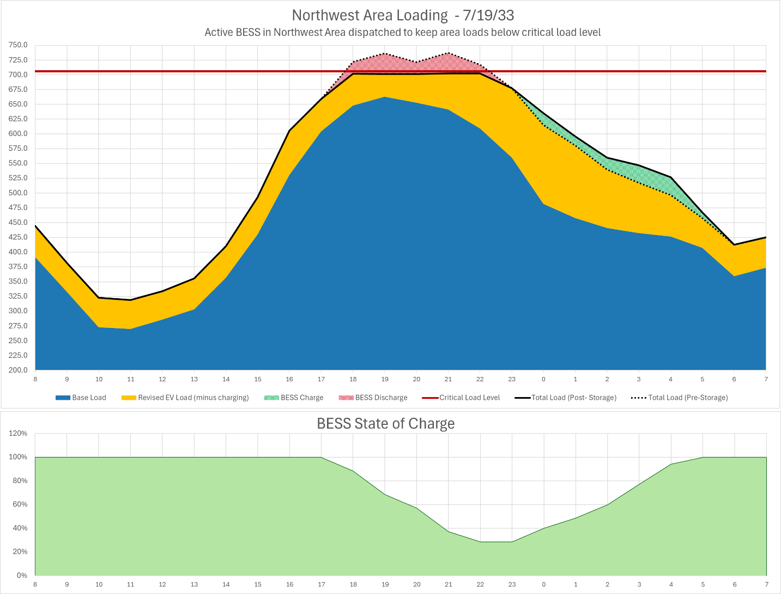
Figure 7: Northwest area loads following EV management and storage dispatch.

NTA Working Group Recommendations:
The timing of the reliability concerns that were identified in the 2024 LRTP are dependent on the timing and extent of load growth due to EV and heat pump adoption. GMP and the VSPC recommend the following actions be taken.
Northern Area: The existing 50.3 MW/167.1 MWh of storage in the Northern area should continue to be dispatched as a load reducer in the manner that it is dispatched today. GMP’s existing Rate 72 and Rate 74 EV charging programs may need to be revised to encourage more charging in the late evening and early morning hours to reduce peak loads. Any revisions to EV charging programs should consider the most recent and up to date system forecasts.
Northwest Area: The existing 62.5 MW/206 MWh of storage in the Northwest area should continue to be dispatched as a load reducer in the manner that it is dispatched today. GMP’s existing Rate 72 and Rate 74 EV charging programs may need to be revised to encourage more charging in the late evening and early morning hours to reduce peak loads. Any revisions to EV charging programs should consider the most recent and up to date system forecasts.
In addition to these actions, the affected DUs should continue to track the metrics below across their systems. VELCO can support these efforts by continuing to define and refine data requirements for these technologies to be included in future transmission planning studies.
- EV charging management enrollment rates, expressed as a percentage of total vehicles within each service territory.
- Customer Opt-out rates for those enrolled in EV charging management programs.
- Coincident peak EV load reductions, quantified as the megawatts of EV charging reduced during system peak hours because of management programs.
- Planned program refinements, including changes to Time-Of-Use windows, event frequency, event duration, etc.)
- Behind-the-meter (BTM) and utility scale storage capacity, reported in MW/MWh at each substation or bus, along with associated control strategies and dispatch methodologies.
- Available flexible load capacity, including C&I customers, reported in MW/MWh at each substation and operational strategy used to call these events.

Should the EV load growth occur at levels projected in the 2024 LRTP, the DUs will have to modify their existing EV TOU programs to shift peak loading hours later into the evening and to reduce any new peaks that are caused at the end of the TOU window, when all vehicles begin charging at the same time. These changes can be made in a couple of different ways:

- DUs could use a DERMS software that will ensure all vehicles are charged by the morning hours when drivers need them, but the DERMS software manages when this charging occurs to better spread out the effect of this load coming online each night, thus reducing the bounce back effect of a TOU program.
- DUs could implement a TOU program that has multiple staggered TOU windows (with on peak hours of 3pm-12am, 4pm-1am, 5pm-2am, for example) to more evenly distribute the impact of many vehicles coming online during the off-peak hours.

Additional Factors Reducing the Need for Transmission Solution

The results of the 2024 LRTP are dependent on the assumptions that were used when its analysis was performed, and therefore the results of this NTA study are dependent on those assumptions coming to fruition. There are numerous additional factors at play that reduce the need for a transmission solution for the Northern and Northwest areas, not limited to the following:
- Revised EV load projects: The updated 2026 load forecast reflects a significant reduction in near-term EV load growth, with the adoption rate of EVs shifting until later in the 2030s. This forecast will be used in the 2027 LRTP.
- Revised heat pump impacts: The updated 2026 forecast also shows a large reduction in projected heat pump coincident peak loads, particularly in areas with natural gas service like the Champlain Valley. This change will be reflected in the 2027 LRTP.
- Proposed storage additions: There is currently 35.2 MW/140.2 MWh of proposed utility-scale storage in GMP’s territory in the Northern Area and 50.2 MW/ 200.2 MWh of proposed storage in GMP’s territory in the Northwestern Area. Because storage can be implemented relatively quickly, GMP’s queue does not typically include projects on the 10-year horizon. Therefore it is reasonable to consider that interconnected storage in 10 years will be much greater than the sum of currently proposed projects. These additions increase operational flexibility and provide greater margin of error for dispatching storage to shift peaks away from the evening and early morning hours.
- Growth in behind-the-meter storage: Continued adoption of behind-the-meter storage for resiliency purposes is expected to further increase the amount of load that GMP can shift during peak hours.
- ISO-NE Planning Procedure 7 revisions will allow for winter planning ratings to be based on a lower ambient air rating than today, increasing winter ampacities on subtransmission and transmission. Further, FERC Order 881 calls for real-time operational ratings to be based on ambient temperatures. For winter concerns, like in the Northern area, this will result in further margins since peak loads only occur on the coldest days.

The 2027 Long Range Transmission Plan will feature the following assumptions that reflect the work performed by VELCO, GMP, and the other DUs as part of the 2024 LRTP cycle and the 2024 NTA analysis:
- An updated forecast that shows a significantly lower projection of EV adoption across the state pending the removal of federal EV incentives.
- An updated forecast that reduces the load contributions of heat pumps in the winter months as a result of the findings of the Ridgeline Heat Pump Study conducted for the Department of Public Service.
- Inclusion of existing TOU EV charging programs as part of the base-line load shape, applied to fully electric EVs at the enrollment rates that are consistent with enrollment rates GMP projected in its 2024 IRP and the 2024 NTA analysis.
- Inclusion of peak-shifting storage, FLM, and event-based EV programs as part of the LRTP study process. This effort captures the resources that are already available on the system today and that are used blindly of transmission needs to reduce costs for customers on the distribution system.

The Plan also identified two other potential reliability concerns, but their timing is outside of the 10-year horizon and further analysis is not needed at this time.
The revised charging curve is discussed later in this Reliability Plan. This illustrative curve shows how existing TOU and event-based programs could be revised to shift charging loads later into the night if EV loads grow as they are projected in the 2024 LRTP.
The forecast that was used in the 2024 LRTP shows significantly more growth in EV and heat pump loads in the 2033 study year than the updated forecast that will be used in the 2027 LRTP. The 2024 load forecast was used in this analysis, although the revised 2027 forecast could change the need to revise EV charging control programs.

